**COMPUTER SCIENCE DEPARTMENT MANAGEMENT SYSTEM**

by

Muhammad Murad

Roll No. 45

A report submitted in partial fulfillment of the requirement for the

Degree of Web Engineering in

Master of Computer Science

Examination Committee: Dr. Abdul Basit Khan

## Title Page

Computer Science and Information Technology Department

University of Balochistan

Quetta

August 2017

## Acknowledgements

First of all I am thankful to Allah Almighty, who has always been giving me strength to fulfill all my tasks, then I am thankful to my Parents for their precious prayers and guidance, then I am very thankful to my respected and beloved teacher Dr. Abdul Basit Khan, who has guided me to design CSMS project in a systematic pattern. He has been very kind and helpful throughout this course and this project.

I am also thankful to the chairman of Computer Science and Information Technology, Mr. Khalid Badini, who provided such facilities in our department.

Finally, I am very thankful to my class mates, who have been very co-operative throughout my studies and project as well.

## Abstract

Computer Science Department Management System is aimed to help out the management level staff of the department in terms of record keeping and the use of the Computer to tackle with the records of the Students, Teachers, and the Courses offered.

The CSMS, is a web-based application, implemented using Ruby on Rails. The Entity-Relationship Model is used to design the database for the application. Bootstrap and CSS is applied to the application to beautify the application.

**Table of Contents**

**Chapter Title Page**

Title Page 1

Acknowledgements 2

Abstract 3

1 Entity Relationship Model 6

1.1 Entity and relationship sets 6

1.2 Entity Relationship diagram 8

2 Implementation 9

2.1 Database used 9

2.2 Webserver used 9

2.3 Server side script used 9

3 Implementing Models 10

3.1 Setting up Routes 10

3.2 Implementing Instructors Model 11

3.2.1 Controller 11

3.2.2 Model 11

3.2.3 Views 12

3.2.4 Association 13

3.3 Implementing Courses Model 14

3.3.1 Controller 14

3.3.2 Model 14

3.3.3 Views 15

3.3.4 Association 16

3.4 Implementing Teaches Model 17

3.4.1 Controller 17

3.4.2 Model 17

3.4.3 Views 18

3.4.4 Association 18

3.5 Implementing Students Model 19

3.5.1 Controller 19

3.5.2 Model 19

3.5.3 Views 20

Association 21

3.6 Implementing Takes Model 22

3.6.1 Controller 22

3.6.2 Model 22

3.6.3 Views 23

3.6.4 Association 23

3.7 Implementing Programs Model 24

3.7.1 Controller 24

3.7.2 Model 24

3.7.3 Views 25

3.7.4 Association 26

3.8 Implementing Designations Model 27

3.8.1 Controller 27

3.8.2 Model 27

3.8.3 Views 28

3.8.4 Association 29

**Chapter 1**

# Entity Relationship Model

MS Access 2013 is used to develop the Entity Relationship Model.

## Entity and relationship sets

**Instructor**

Instructor is an entity their store all information about instructor name, gender, address etc.

**Student**

Student is an entity their stores all information about student like name, gender, contact, address, etc.

**Course**

Course is an entity their stores all information about course like course title, duration, etc.

**Program**

**P**rogram is an entity their all information store about room program_id, title, semesters etc.

**Designation**

Designation is an entity their all information store about designation like designation title, grade, salary etc.

**Instructor and course**

Instructor and course each relationships are many to one .here instructor is primary key and course is foreign key

teaches

Instructor

Course

**Course and student**

Course and Student each relationships is many to many .here student is primary key and course is foreign key.

Course

takes

Student

**Student and program**

Student and program each relationship is many too one .here course is primary key and student is foreign key

Program

has

Student

**Instructor and Designation**

The relationship between Instructor and designation many to one

Instructor

has

Designation

## Entity Relationship diagram

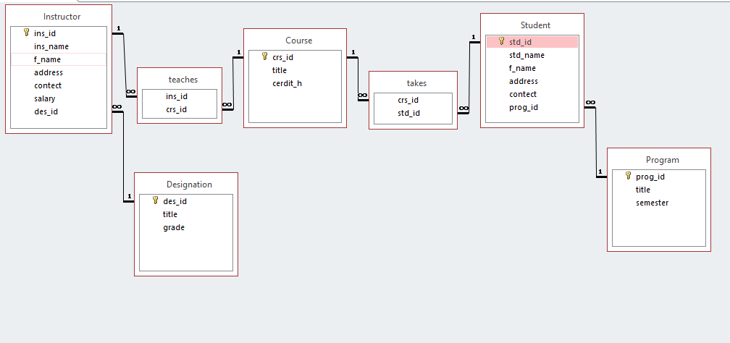

**Chapter 2**

# Implementation

## Database used

PostgreSQL is used for the database purpose. It is an open source database tool, which is already included in the package of Ruby on Rails.

## Webserver used

PUMA server is offered as a default server in Ruby on Rails. PUMA server is used in this application.

## Server side script used

HTML and Ruby are used as server side scripting language.

**Chapter 3**

# Implementing Models

We discuss about the reduction of entity relationship diagram to relational schema in this chapter.

## Setting up Routes

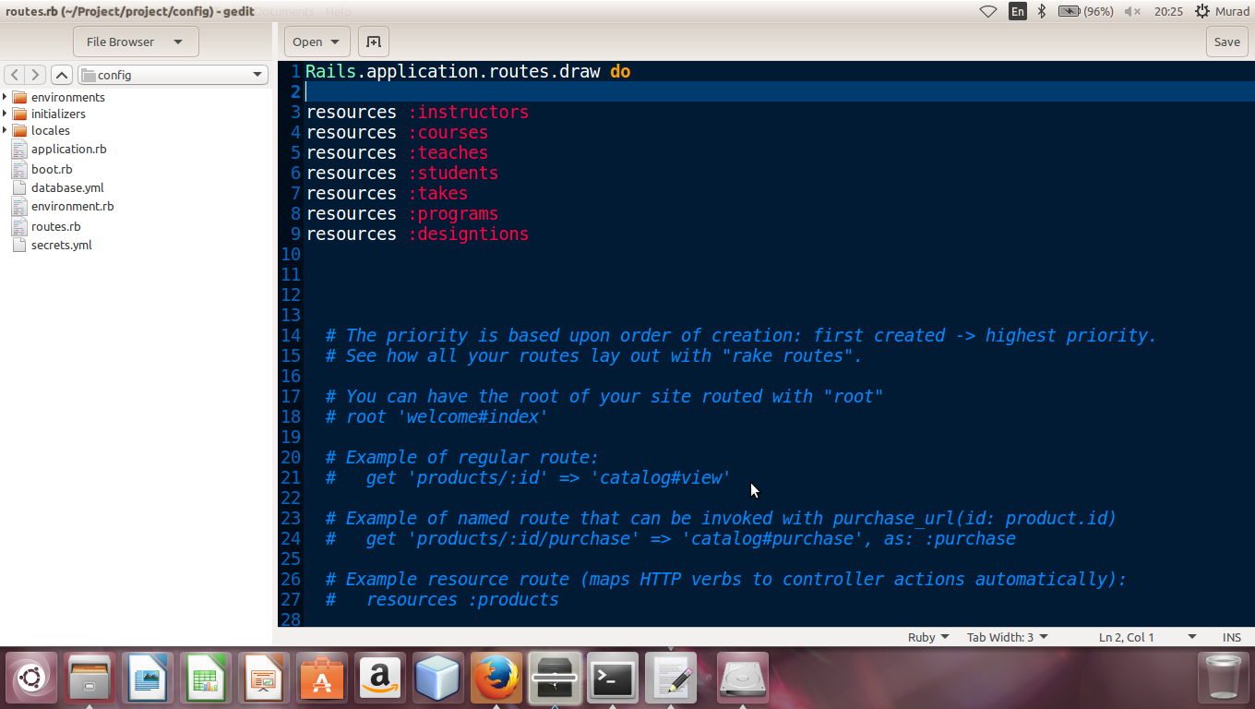

## Implementing Instructors Model

After defining the routes for Instructors Model, the controller for Instructors is developed. All the methods are defined in the controller, then the model is developed for Instructors and then the web pages are developed in Views. At the end the associations are declared.

### Controller

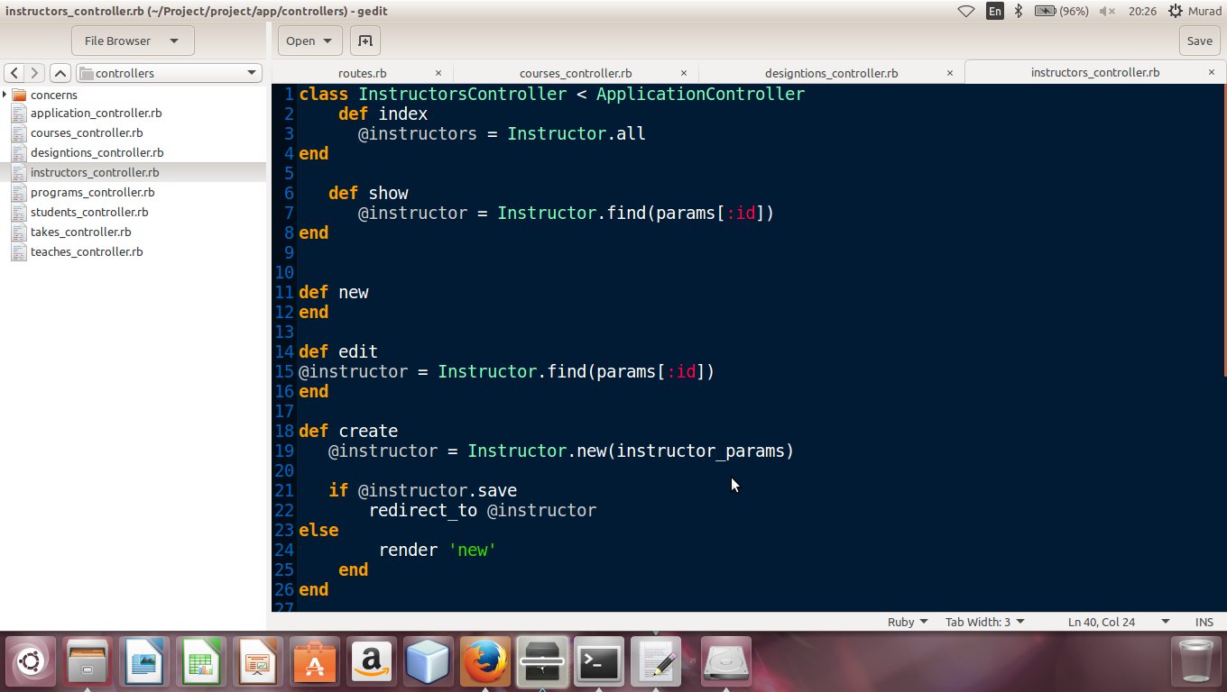

### Model

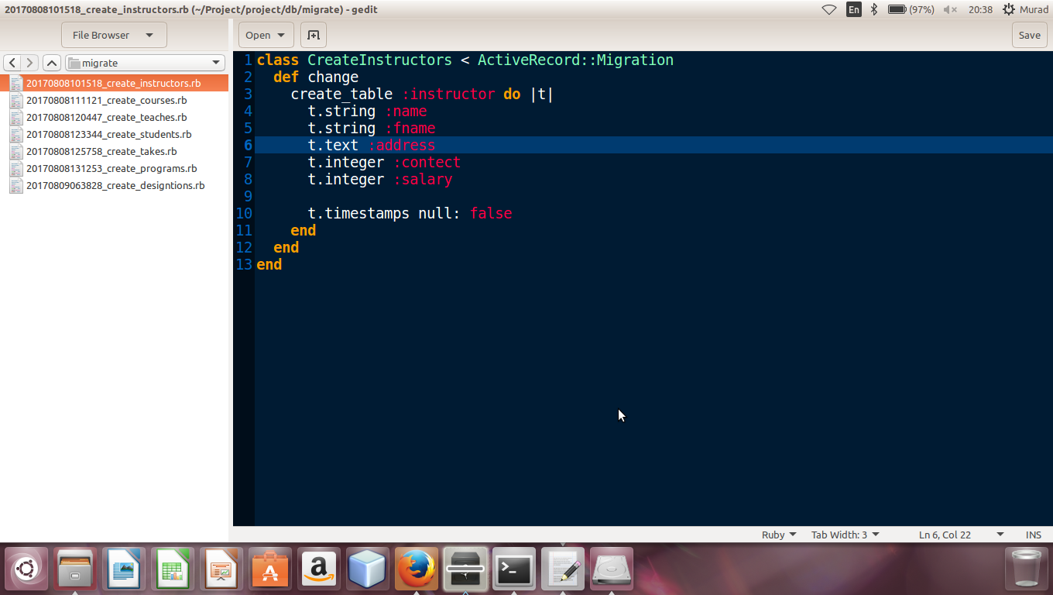

### Views

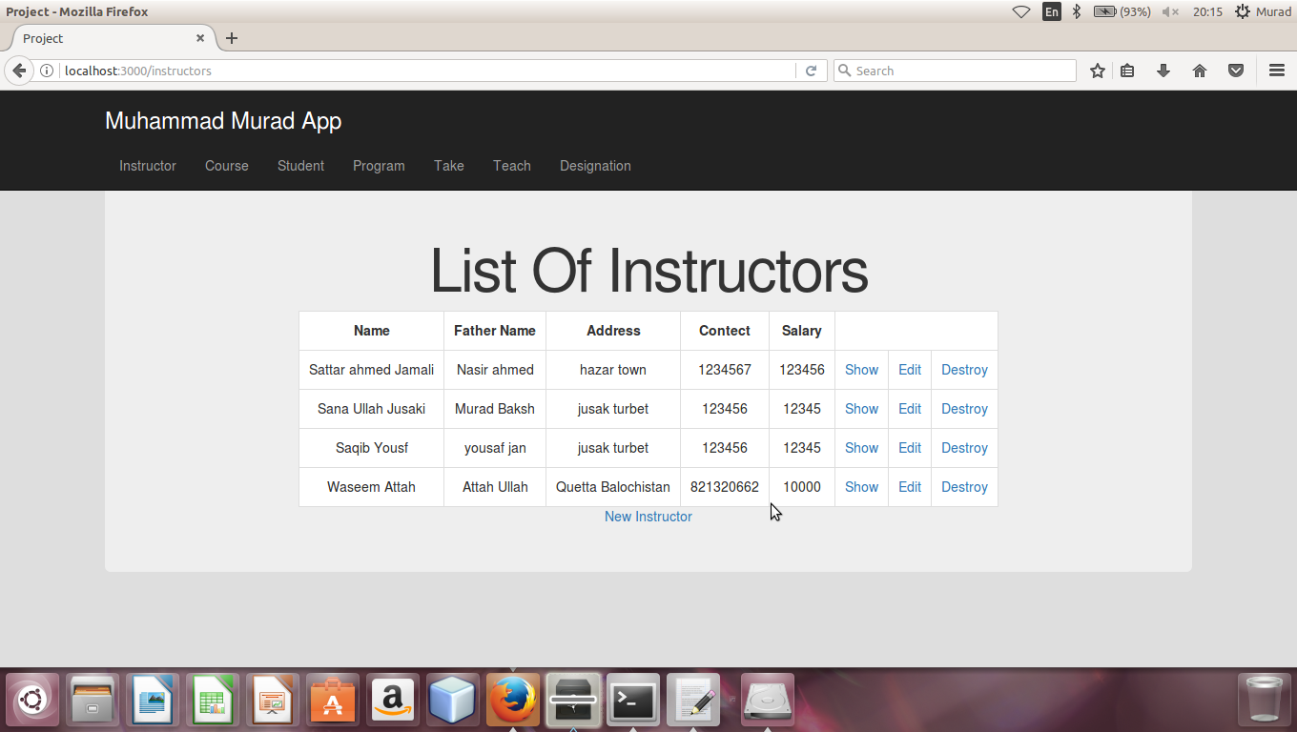

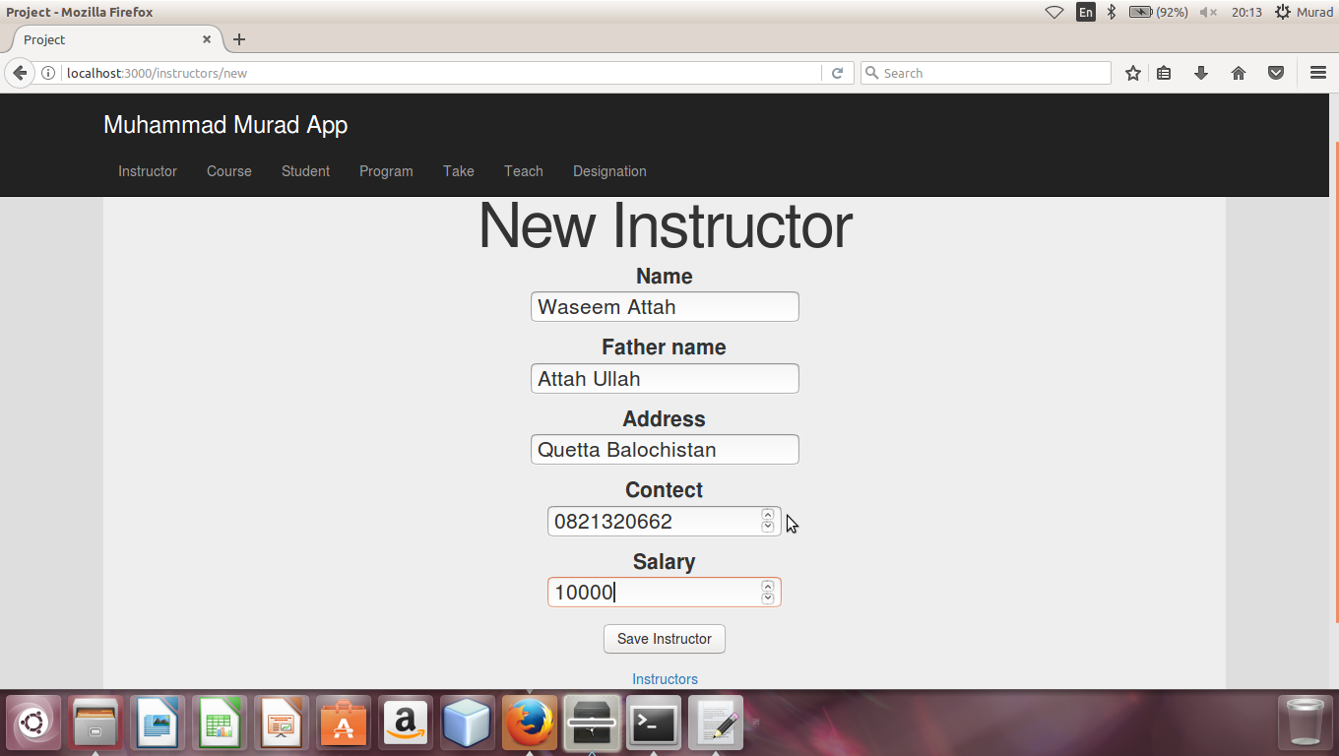

### Association

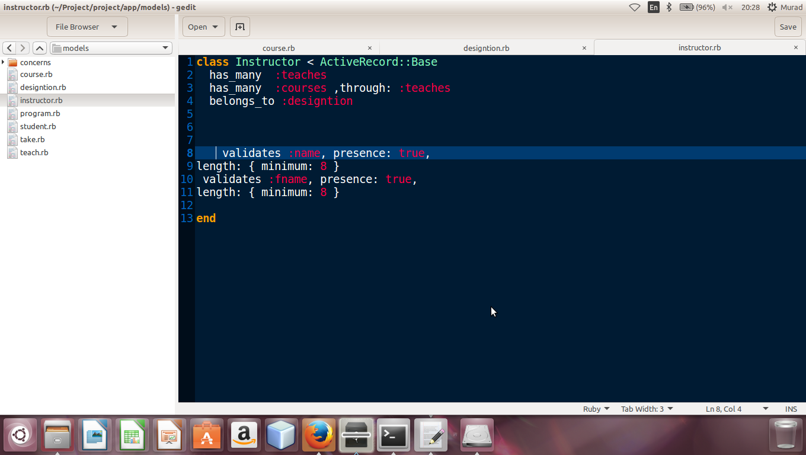

## Implementing Courses Model

After defining the routes for Courses Model, the controller for Courses is developed. All the methods are defined in the controller, then the model is developed for Courses and then the web pages are developed in Views. At the end the associations are declared

### Controller

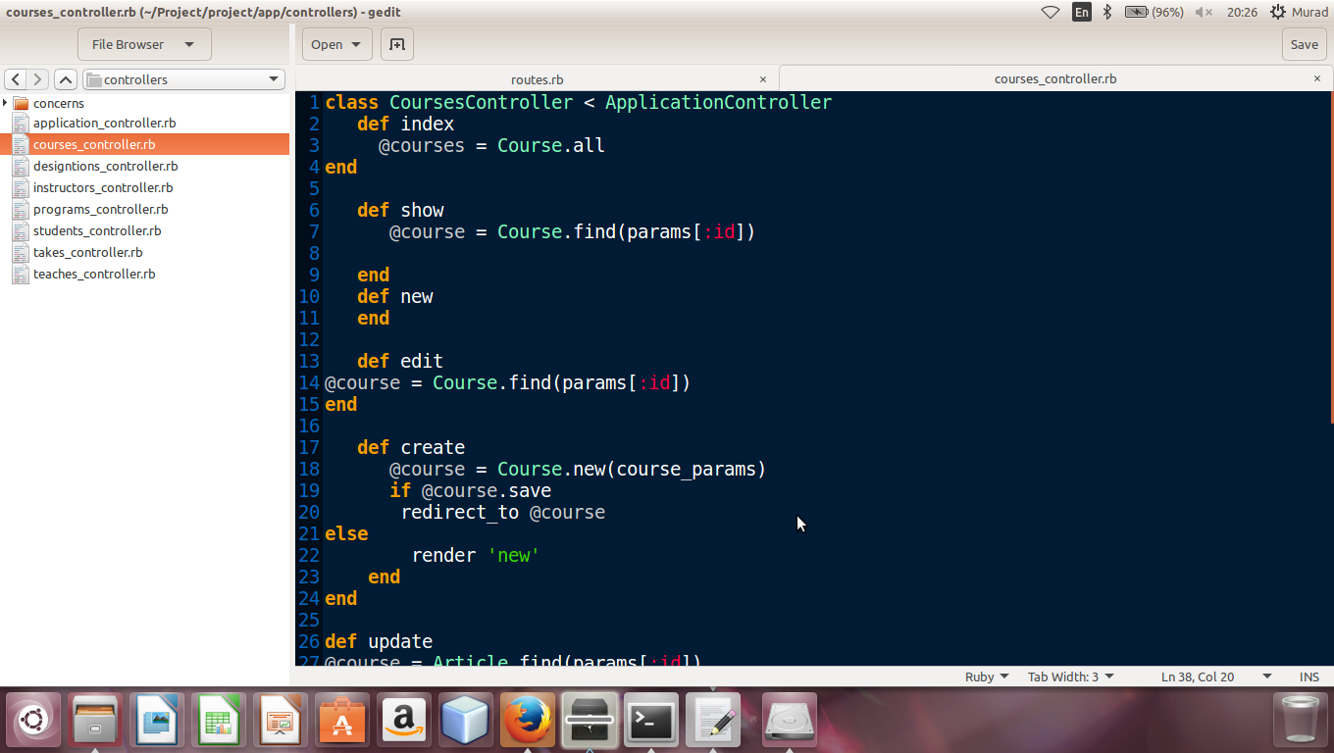

### Model

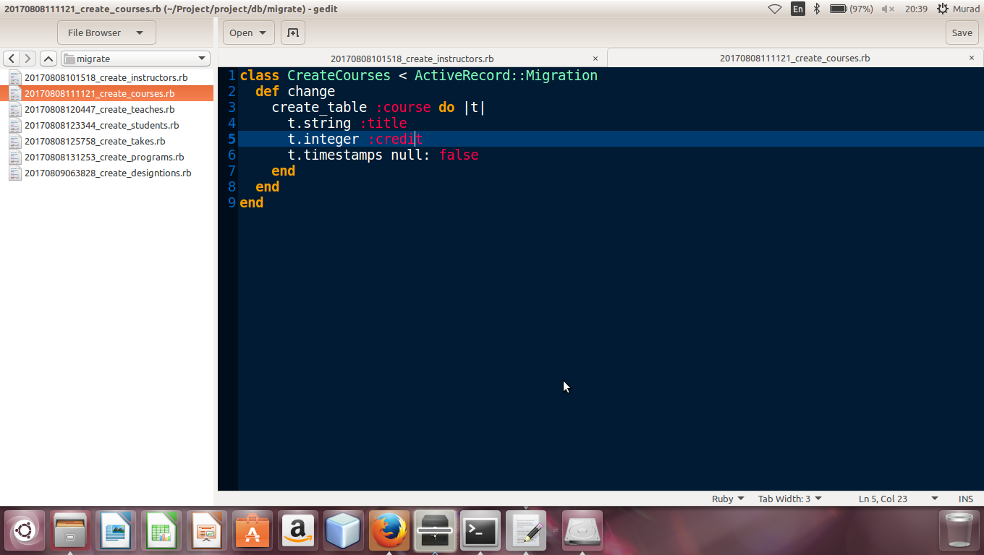

### Views

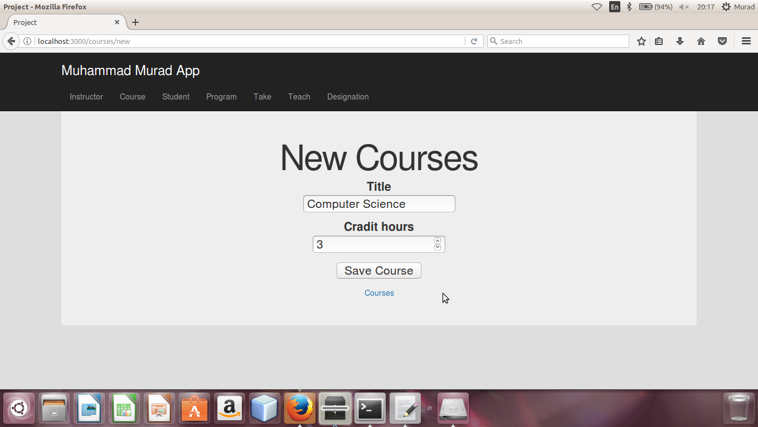

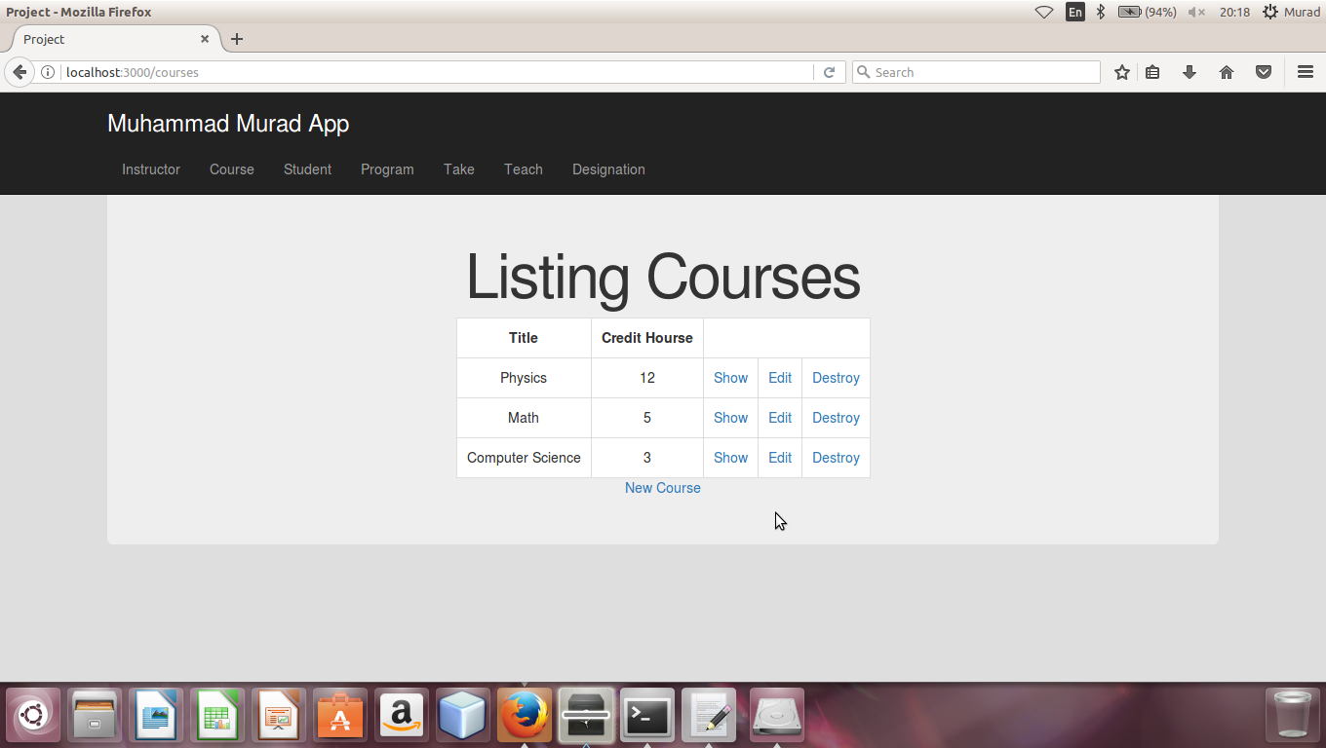

### Association



## Implementing Teaches Model

After defining the routes for Teachers Model, the controller for Teaches is developed. All the methods are defined in the controller, then the model is developed for Teachers and then the web pages are developed in Views. At the end the associations are declared

### Controller

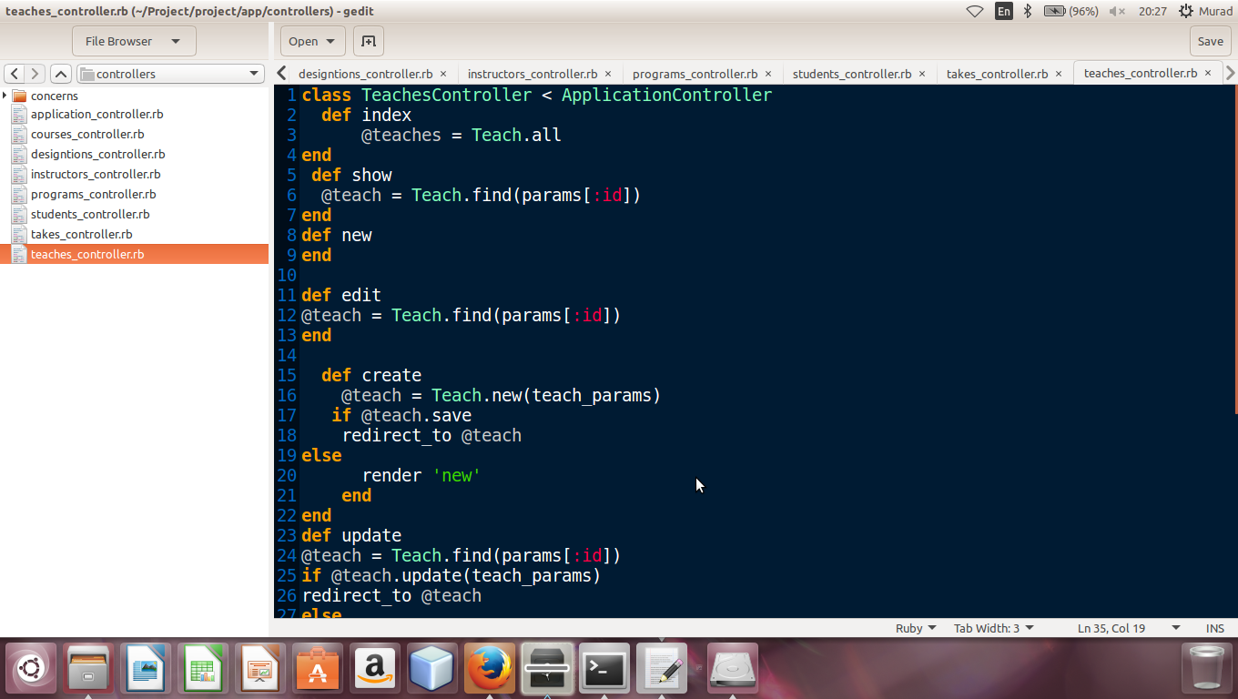

### Model

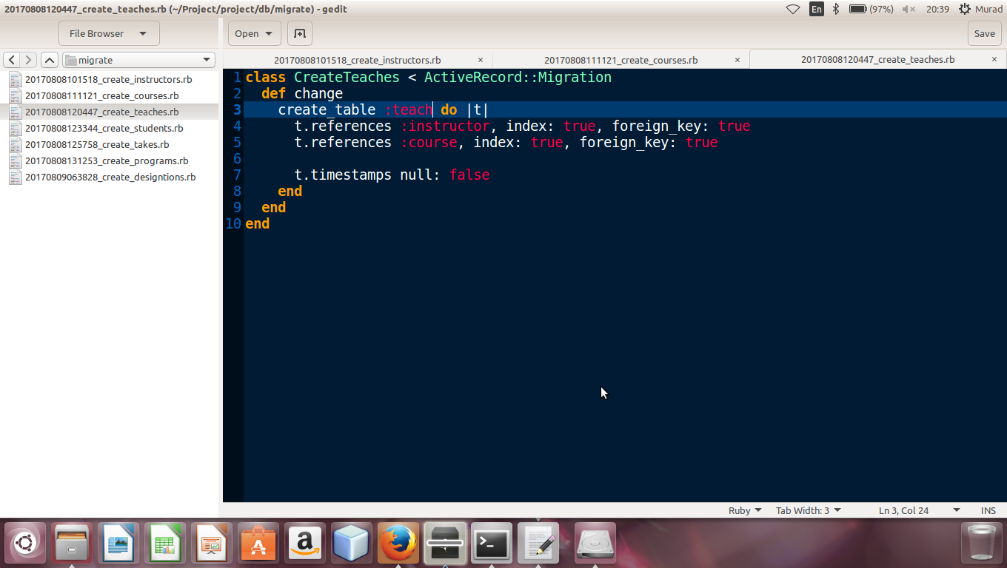

### Views

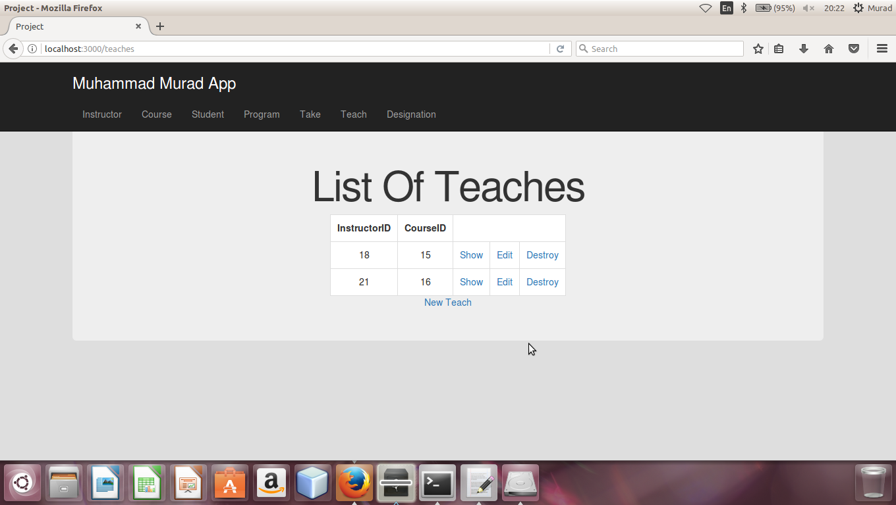

### Association

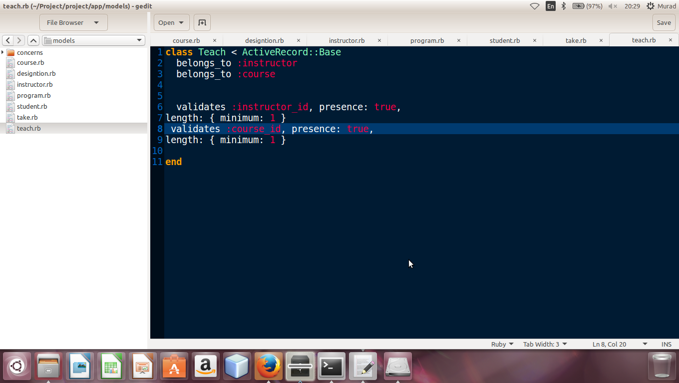

## Implementing Students Model

After defining the routes for Students Model, the controller for Instructors is developed. All the methods are defined in the controller, then the model is developed for Students and then the web pages are developed in Views. At the end the associations are declared

### Controller

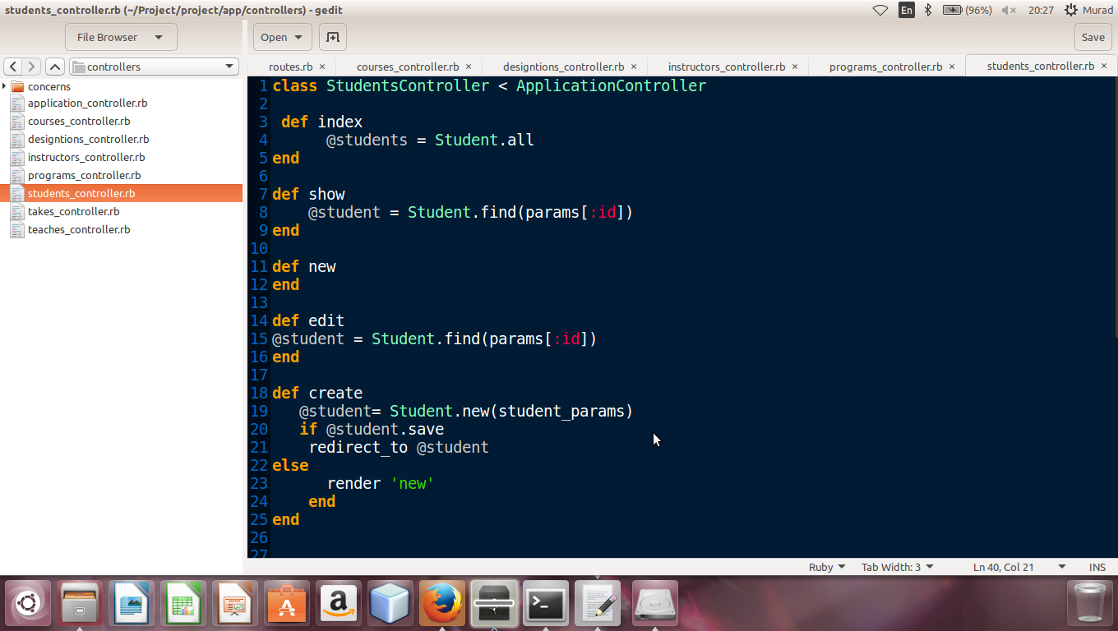

### Model

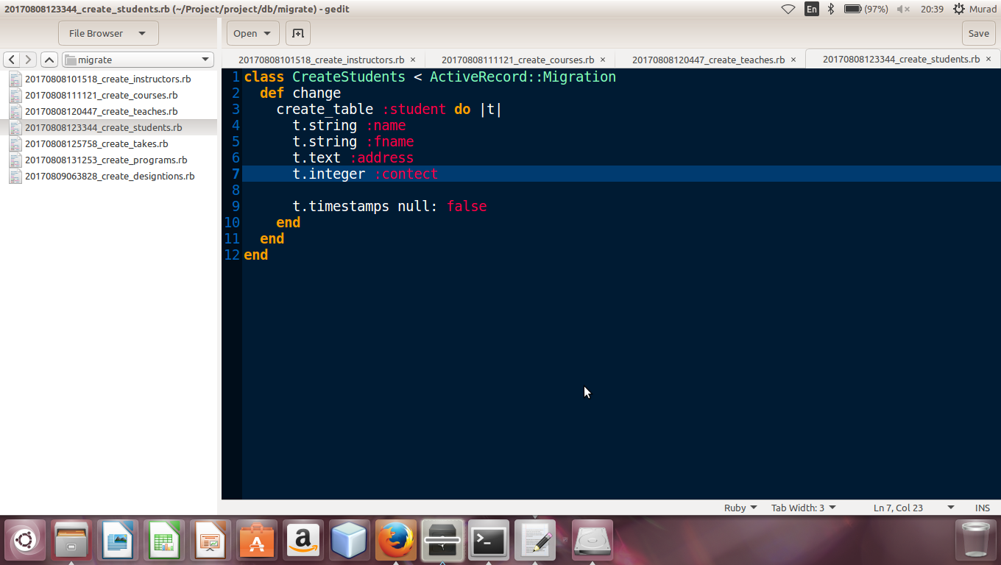

### Views

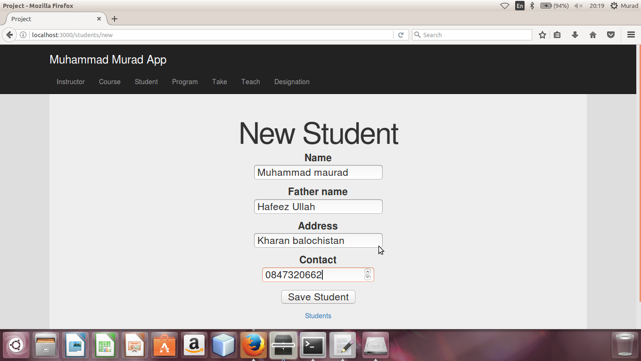

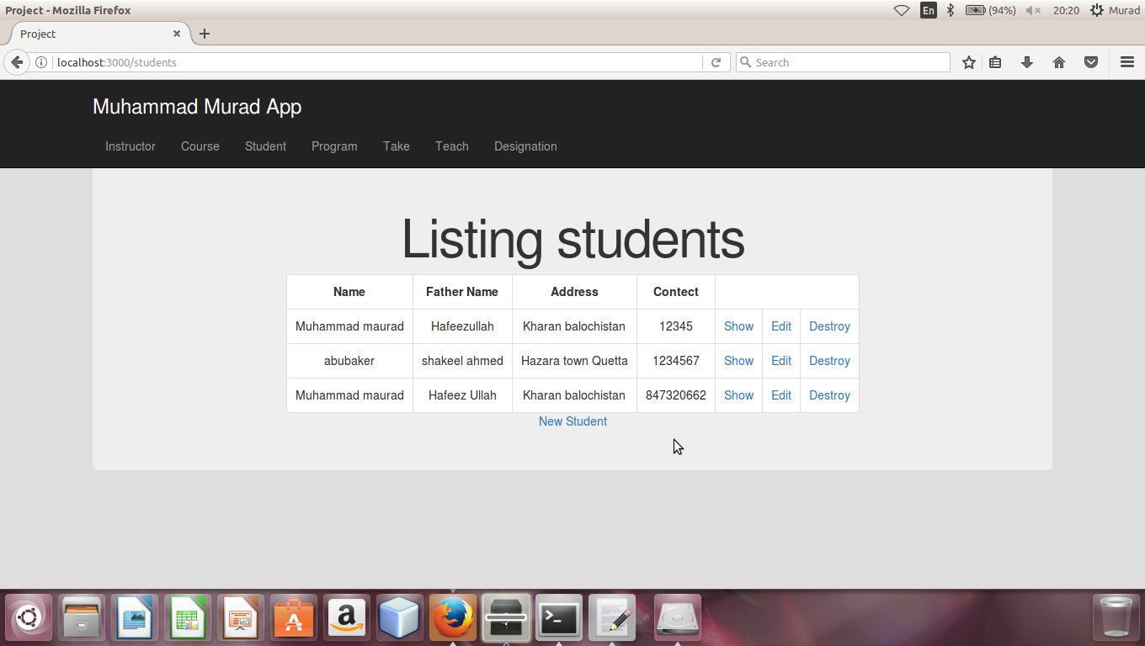

### Association

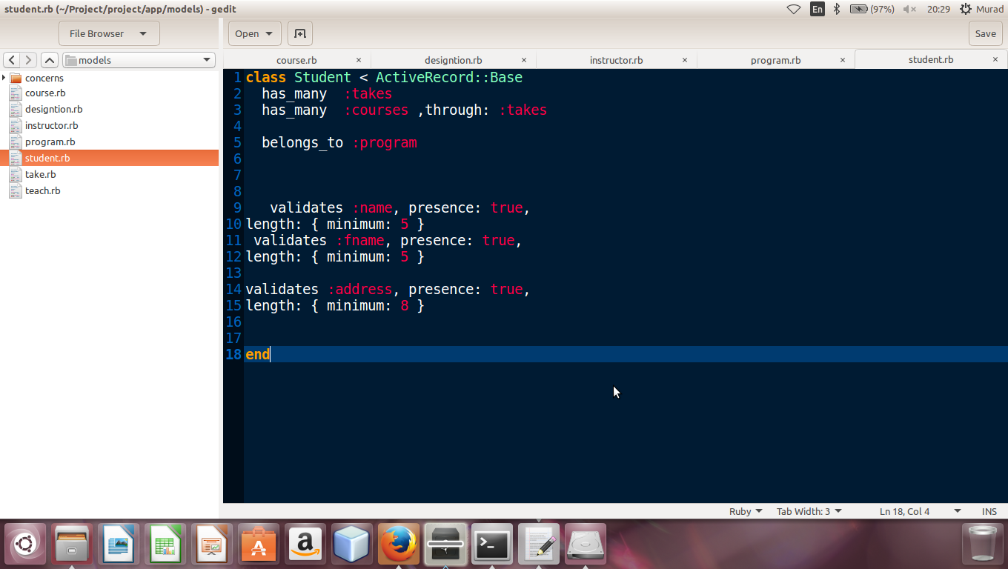

## Implementing Takes Model

After defining the routes for Takes Model, the controller for Takes is developed. All the methods are defined in the controller, then the model is developed for Takes and then the web pages are developed in Views. At the end the associations are declared

### Controller

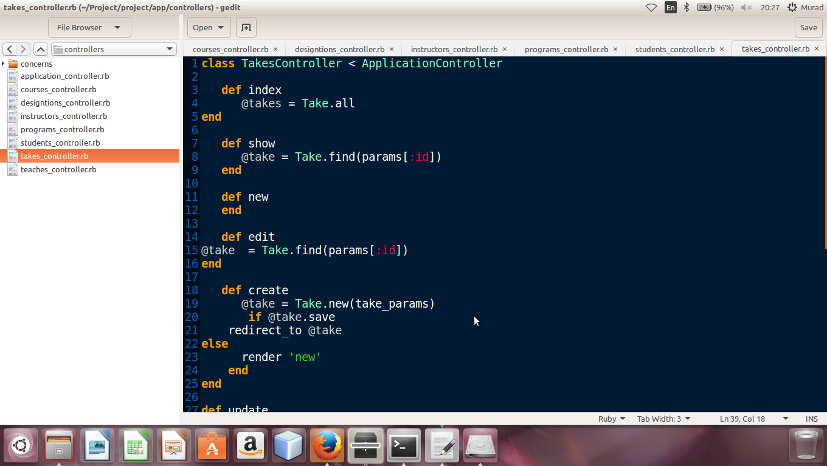

### Model

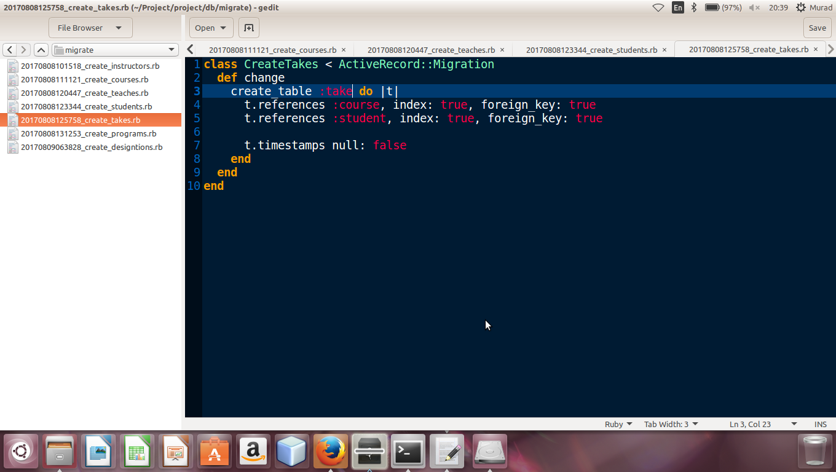

### Views

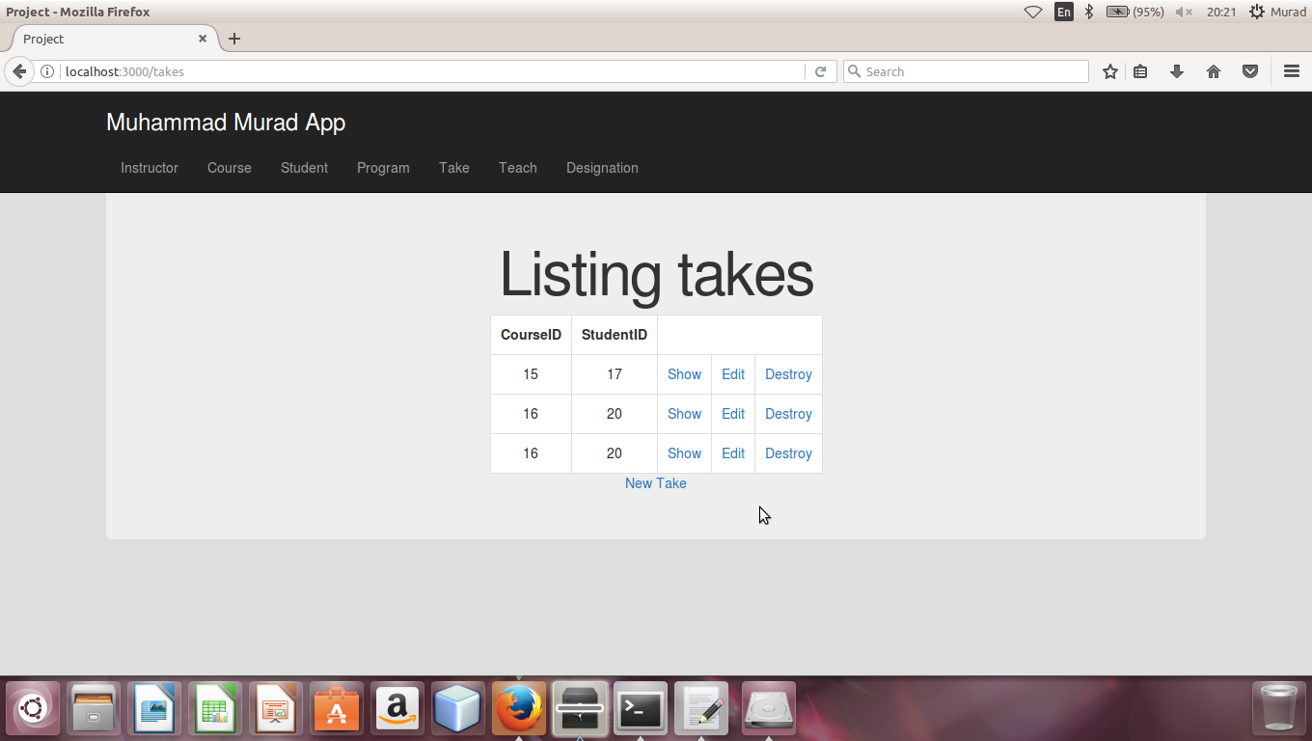

### Association

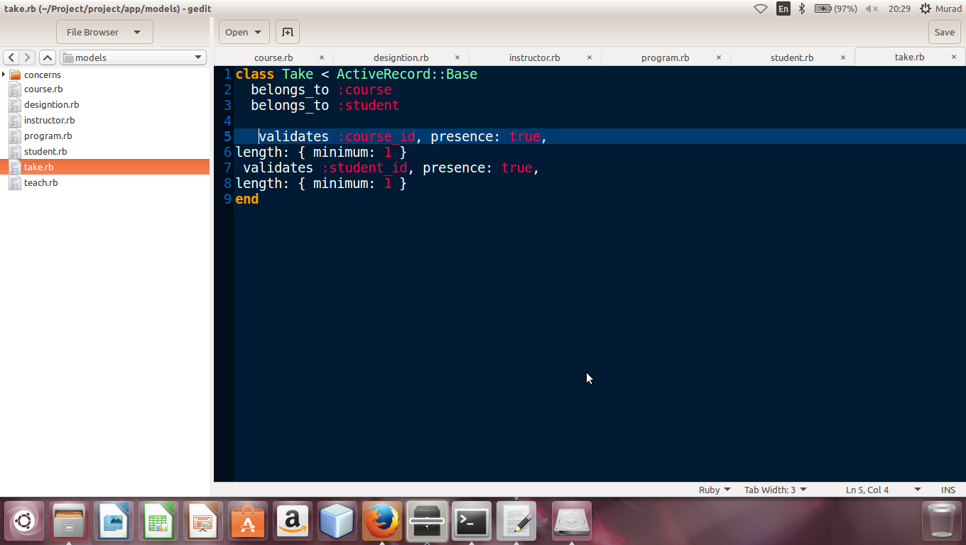

## Implementing Programs Model

After defining the routes for Programs Model, the controller for Programs is developed. All the methods are defined in the controller, then the model is developed for Programs and then the web pages are developed in Views. At the end the associations are declared

### Controller

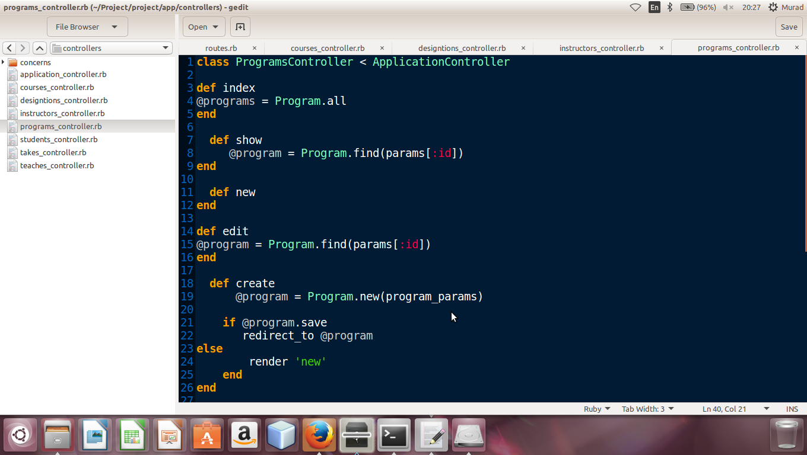

### Model

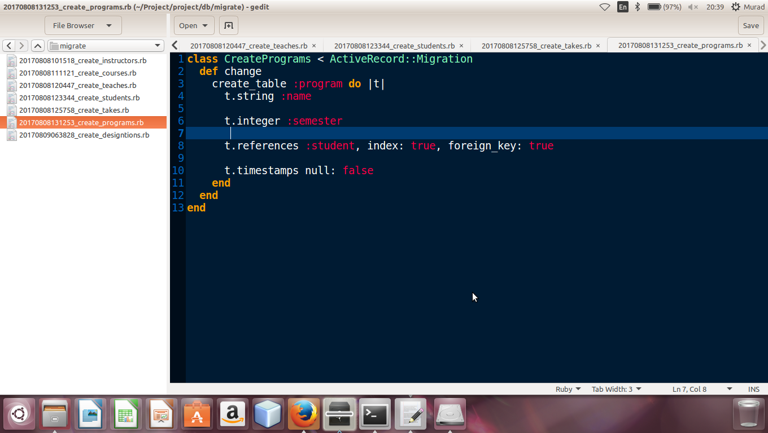

### Views

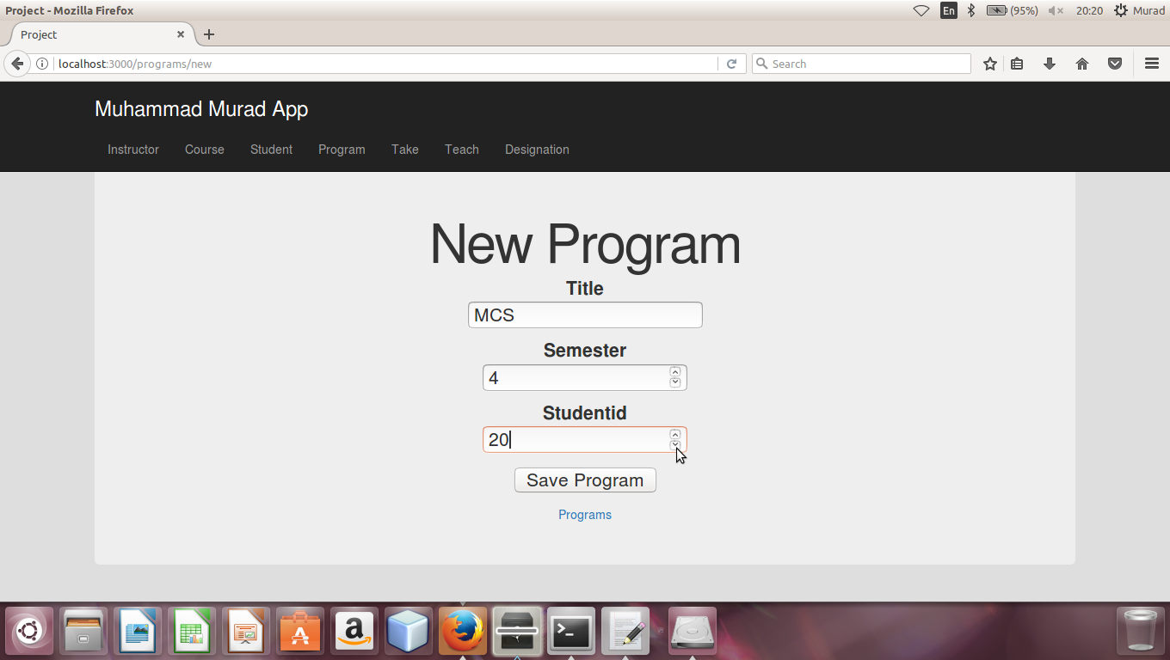

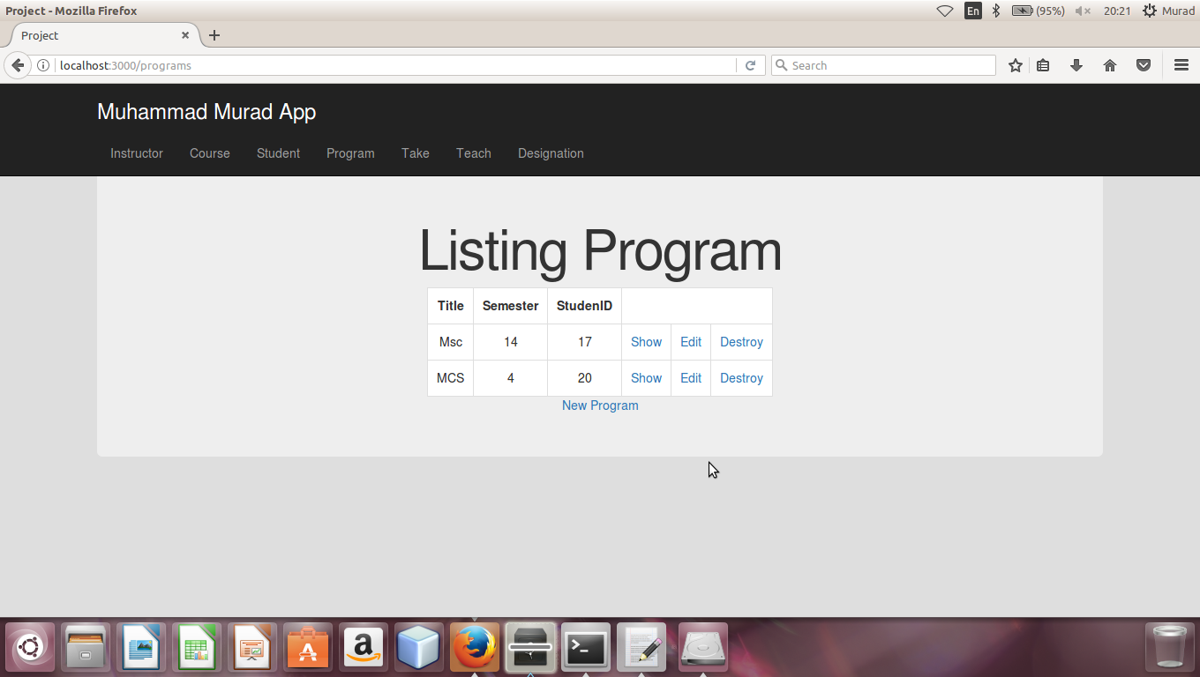

### Association

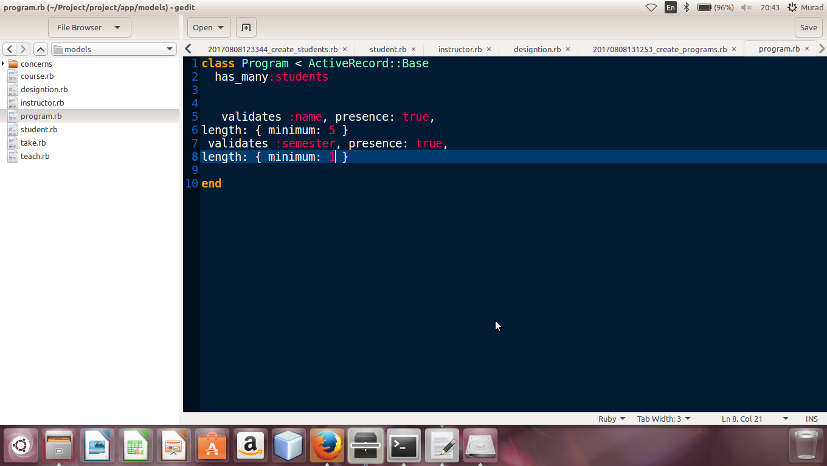

## Implementing Designations Model

After defining the routes for Designations Model, the controller for Designations is developed. All the methods are defined in the controller, then the model is developed for Designations and then the web pages are developed in Views. At the end the associations are declared

### Controller

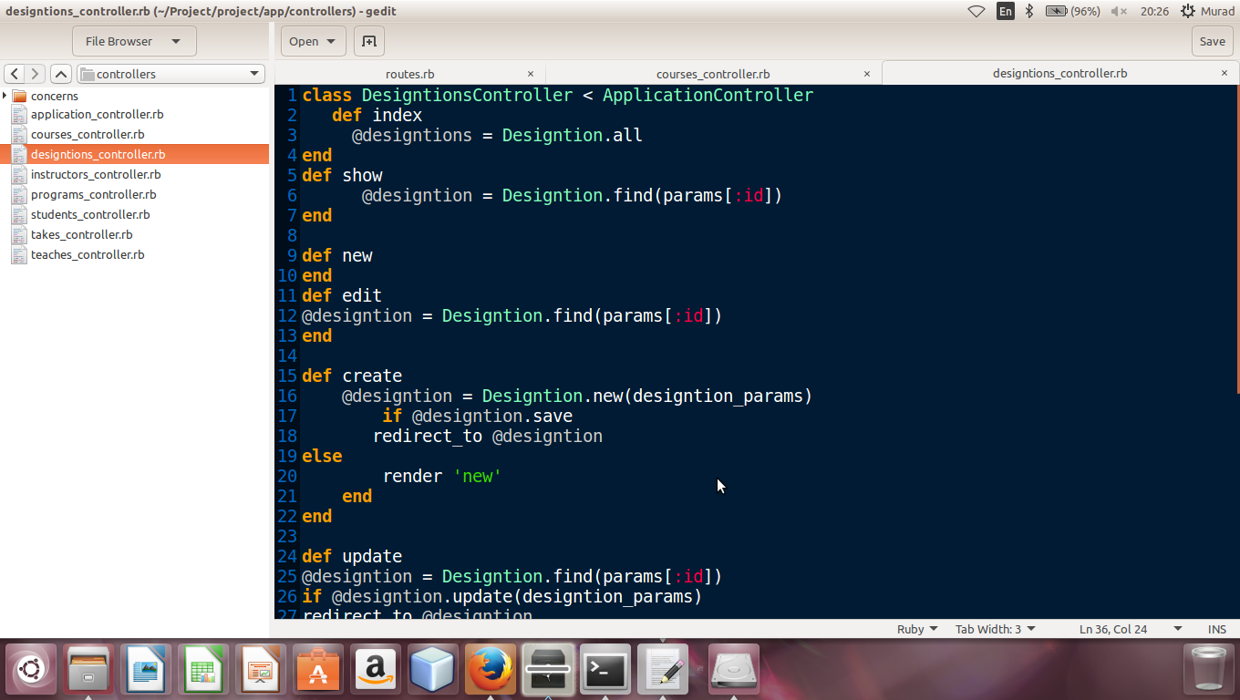

### Model

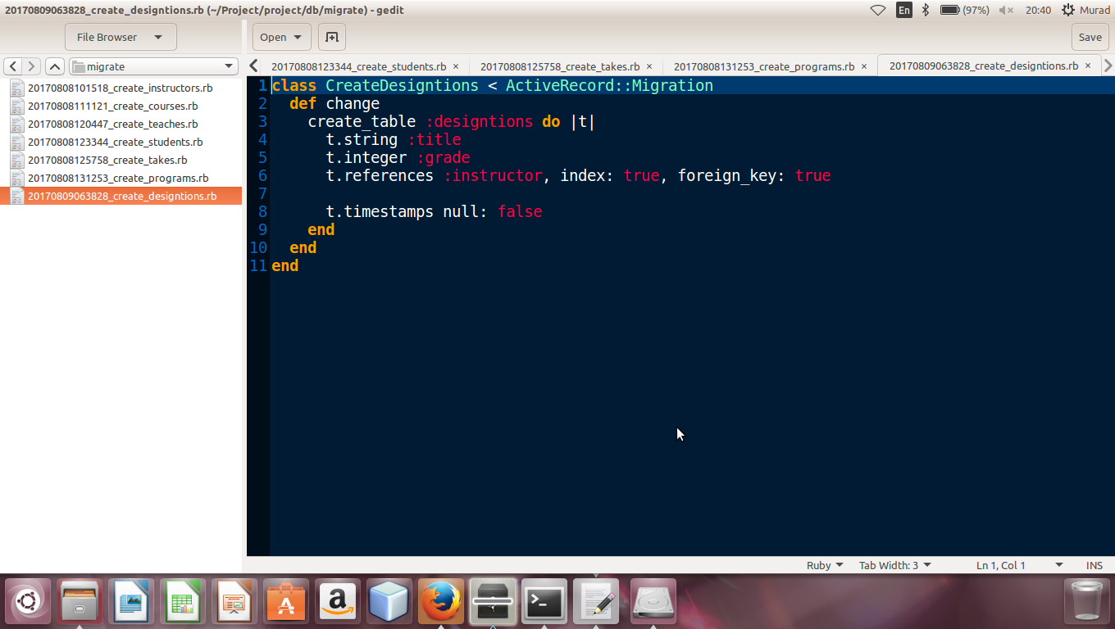

### Views

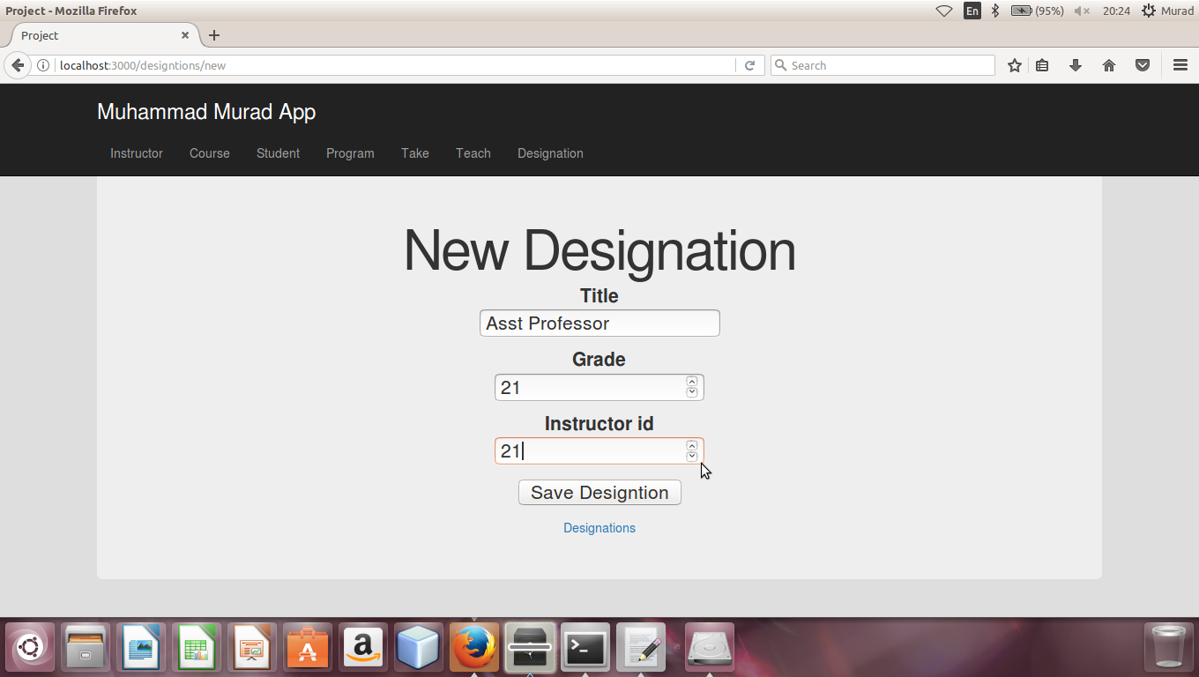

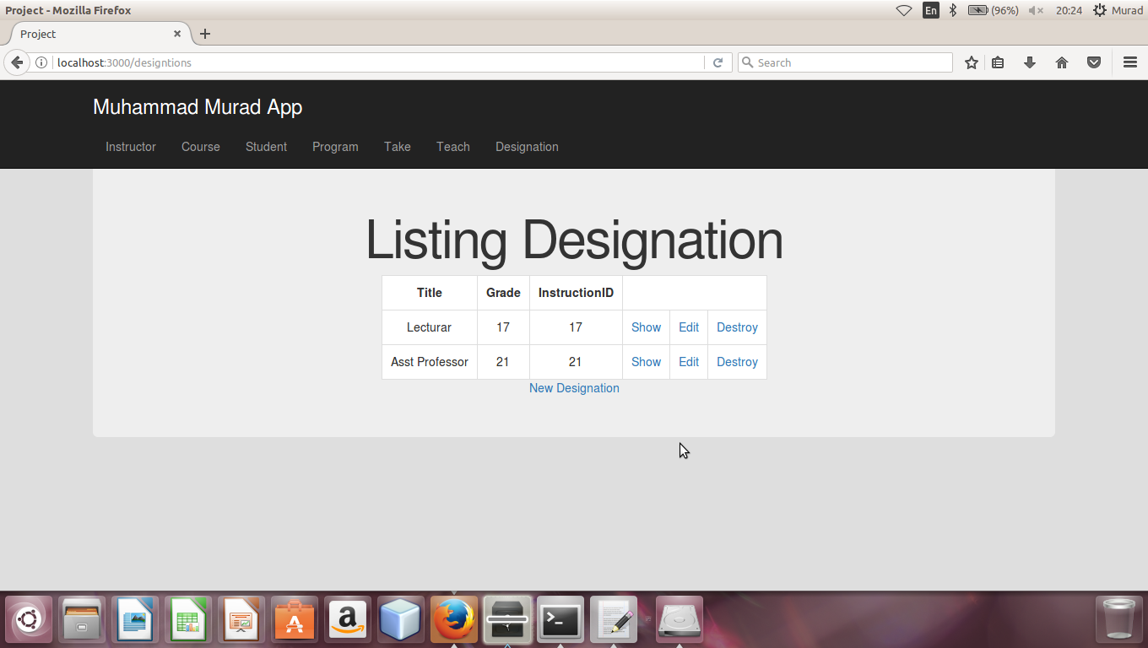

### Association

